# **PROJECT DETAILS**

|  |  |
| --- | --- |
| Project ID | 4257-MYP/10140 |
| Project Name | Strengthening Ear and Hearing Care Services in Ethiopia |
| Project Location | Addis Ababa, Ethiopia, East Africa |
| Project Duration | Three years (2022-2024) |
| Total approved budget amount (in EUR) | <1,078,817.48 > |
| Total budget expenditure amount (in EUR) | <50,195.95 > |
| Contract Partner | <St. Paul Hospital Millenium Medical College> |
| Other Implementing Partners | <N/A)> |
| Responsible person at Partner / Project | Netsanet Tekalign-Administration/program Assistant  Dr Bisrat Getachew, MD, Assistant.Prof.ORL-HNS, SPHMMC,  EHC Project Coordinator |
| Date of report submission | Jul 17, 2024 |
| ` | <Samuel Bekele, CO Programme Officer> |

1. **NARRATIVE REPORT**

# **Summary of Results Achievements**

CBM and SPHMMC signed a new three-year continuation of their multiyear project plan (MYP) in 2022. This year marks the final year of the project's implementation. The project aims to achieve changes in five key result areas, as outlined in the indicators for each area. These major result areas include service provision, capacity building, health education and promotion, mainstreaming EHC through partnerships with key government stakeholders, and efficient and effective project management. The activities planned for the first and second quarters, which are crucial for the project's progress and success, have been completed. The summary of the activities implemented in the first six months of 2024 is provided below.

**Result Area 1: High quality EHC service is provided to the target population nationally**

During the reporting period, the project successfully conducted Outreach Screening, Audiometry Screening, Clinical Screening, and Micro Ear Surgery campaigns. Outreach Screening Campaigns were held at Sendafa Health Center in both quarters, German Church School and Lideta Health Center in the 1st quarter, Alembank HC in both quarters, and Burayu Health Center in the 2nd quarter. A total of 1,098 individuals were screened during these outreach programs over the two quarters.

Clinical Screening and surgeries took place at CURE Children's Hospital in Addis Ababa and the base hospital (SPHMMC). Audiology testing was conducted for 1,086 individuals (578 females). Clinical screenings identified potential ear and hearing problems in 2,528 individuals (1,285 females). Surgery campaigns resulted in 206 surgeries (112 females) at the base hospital (SPHMMC) over the two quarters. Additionally, 229 screenings and 63 surgeries were performed at CURE Children's Hospital.

Assistive hearing aids were provided to 6 patients (5 females and 1 male). The number of hearing aid fittings remains low due to the software for fitting hearing aids not being the appropriate one. Additionally, hearing aid repairs were made for 4 females and 2 males.

In the 1st quarter of this year, the project also held a dissemination workshop for the National Population-Based Hearing Impairment Survey. The results were shared with partner organizations during the World Hearing Day 2024 celebrations. This year, the project plans to print and distribute copies of the survey to Regional Health Offices, managed by the Country Office. It is believed that the survey results will aid in need-based planning and developing action plans to address ear and hearing problems.

**Result Area 2; Capacity building system will be established by providing training for Ear and Hearing Care (EHC) to Health Personnel.**

In previous years, the project recruited 1 senior ENT surgeon, 2 residents, and 2 nurses. The residents and nurses have completed their online training and are ready to travel to South Africa for a practical session and to finalize their training. However, they have been denied entry visas to South Africa three times. Currently, we are negotiating with the training institution to send their trainer to Ethiopia to conduct the practical training sessions in Addis Ababa.

One of the planned activities under this result area was providing Training of Trainers on common ENT health problems and Primary Ear and Hearing Care, which was successfully implemented. Out of 25 invited participants, 21 attended the training. The participants were from health facilities in Addis Ababa, Sheger City, and Gerarbet Tehadiso Mahber Hospital in Butajira. Another planned activity, DiD, Gender mainstreaming, and Child Safeguarding training, was postponed to the first week of the third quarter due to scheduling conflicts with the trainers. budget

**Result Area 3: Strengthening the Health Education & Promotion System on Ear and Hearing Care (EHC)**

Under this result area, the project implemented awareness-raising campaigns alongside outreach screening campaigns in both quarters at Sendafa HC, Alembank HC, Lideta HC, German School Church, and Burayu HC, reaching approximately 1,796 people.

Additionally, World Hearing Day (WHD) was celebrated for the sixth time in Ethiopia on March 3rd. This year, 40 participants were invited to the event, with 39 attending. The attendees included representatives from SPHMMC, partner organizations, associations of people living with disabilities, ENT professionals, and the media. During the symposium, promotional IEC/BCC materials such as posters, stickers, and T-shirts were distributed. These materials carried messages focusing on ear and hearing care. This year’s celebration was themed **“CHANGING MINDSETS: Let’s make ear and hearing care a reality for all!”**

Additionally, T-Shirts and flyers and poster with highlighting EHC promotive messages were distributed to the participants. Furthermore, QR code with a message *‘I am Hearing Loss friendly*’ was distributed for symposium participants to directly link to CBM website without downloading its apps. These codes can also facilitate connecting on social media.

**Result Area 4; EHC mainstreamed through partnership with the Federal Ministry of Health of Ethiopia**

Activities under this result area were not planned to be implemented for both quarters.

**Result Area 5; Efficient and effective program management is achieved**

Project management support, salary top ups, and related admin expenses were paid duly in each month to help to facilitate the implementation of planned activities.

# **Narrative Reporting on Activity Implementation**

**Result Area 1; High quality EHC service is provided to the target population Nationally Implementation**

01.02 Implementation of 4 screening outreach nationally

01.03 Perform facility based auditory function screening testing (Neonates/Children/Adults).

01.04 Clinical screening of persons with ear conditions /hearing loss or suppurative otitis media (Neonates/School Children/Adults).

01.05 Provision of assistive devices (hearing instruments and accessories) to 200 patients annually

01.06. Perform 300 ear microsurgeries at SPHMMC and Butajira annually.

**Result Area 2; Capacity building system will be established by providing training for Ear and Hearing Care (EHC) to Health Personnel.**

02.04 Training of 30 General Practitioners/Health officers/Nurses from all over Ethiopia on the diagnosis and management of common ENT problems annually

02.06 Comprehensive security and safeguarding activities.

**Result Area 3; Health education & promotion system on EHC strengthened**

03.02 Four rounds of health education training/ awareness for 100 CBR and urban health extension workers from Butajira, Fiche and selected health centers in Addis Ababa annually.

03.05 Organize 1 symposium on EHC service on world hearing day.

**Result Area 4; EHC mainstreamed through partnership with the Federal Ministry Health of Ethiopia.**

No planned activities under this result area were implemented because establishing a formal partnership with the Ministry of Health (MoH) for mainstreaming efforts or resuming the previously established functional Technical Working Group (TWG) meetings proved challenging. This difficulty was due to the Ministry’s other priorities.

**Result Area 5; Efficient and effective program management is achieved**

05.01 Support proper management (Salary top-up of project director/coordinator)

05.02 Support to administrative costs for project implementation (Salary top-up of finance and admin and program assistant)

05.04 Other related Admin expenses; travel, internet, etc.

**Result Area 1; High quality EHC service is provided to the target population Nationally**

**01.02 Implementation of 4 screening Outreach Nationally**

During the past six months, the project successfully implemented an outreach program in five facilities (four health centers and one school), namely Sendafa HC, Lideta HC, Alem Bank HC, Burayu HC, and German Church School. A total of 1,098 individuals were screened during the campaign, including 203 males, 344 females, 242 boys, and 309 girls. Consultation and treatments were provided on-site, and patients who needed further care were referred to the nearest hospitals within the catchment areas and to St. Paul’s Hospital. According to our half-year plan, we achieved our target of conducting two outreach programs every six months.

**01.03 Perform facility based auditory function screening testing (Neonates/ Children/ Adults).**

In the first two quarters, we conducted auditory function screening tests at St. Paul’s Hospital as planned. A total of 1,086 individuals were screened, comprising 399 men, 109 boys, 477 women, and 101 girls. These screenings were organized through campaigns to accurately identify the number of patients needing medical, surgical, or both interventions, as well as hearing aids or other high-level therapies. The half-year plan aimed to screen 1,000 patients, and the project successfully met 100% of this goal, indicating it is on track to achieve the annual plan.

**01.04 Clinical screening of persons with ear conditions /hearing loss or suppurative otitis media (Neonates/School Children/Adults).**

The clinical screening for ear disease or hearing loss has been planned for all quarters. In the past six months, this screening was conducted at St. Paul’s Hospital and Cure Hospital in Addis Ababa. A total of 2,757 patients were screened at these two facilities. At SPHMMC, 2,528 patients were screened, including 893 males, 958 females, 350 boys, and 327 girls. At Cure Hospital, 229 patients were screened, comprising 92 girls and 137 boys. These patients were assessed for possible ear and hearing problems, as well as other ENT-related issues. The major findings during the screenings included acute otitis media, chronic suppurative otitis media, sensorineural hearing loss, conductive hearing loss, and mixed hearing loss.

In these six months, we managed to screen a total of 2,757 patients for possible ear conditions. The annual plan is to screen 5,000 patients per year (2,500 per quarter), indicating that the project is making good progress towards achieving the annual target.

**01.05 Provision of assistive devices (hearing instruments and accessories) to 200 persons annually**

In the past two quarters, the project managed to fit hearing aids on six patients: two girls received two hearing aids, one male received one hearing aid, and three females received three hearing aids. The six-month plan was to fit hearing aids for 100 persons, but the achievement was significantly lower. This was due to delays in receiving the necessary software for fitting the hearing aids in the first quarter. Although the software was received in the second quarter, it requires a specific programming device that we do not have and is incompatible with the type of hearing aids available.

Additionally, hearing aids were repaired for two girls, two females, and two males. The provision of these devices has not only improved the hearing conditions of the patients but also contributed to enhancing their communication and social interactions. This, in turn, improves their overall quality of life by alleviating stress and embarrassment, as individuals with hearing impairments are often sympathized with due to their condition. Currently, Dr. Uta is attempting to procure the appropriate programming device.

**01.06 Perform 300 ear microsurgeries at SPHMMC and Butajira annually.**

Like the screening tests for clinical and auditory functions, performing micro ear surgeries has been a critical activity. In the past six months, micro ear surgeries were conducted at St. Paul’s Hospital and Cure Children’s Hospital. A total of 269 patients received the necessary surgical procedures, including 76 males, 99 women, 52 boys, and 42 girls. The primary conditions requiring these surgeries were chronic suppurative otitis media, with the majority of the surgeries being tympanoplasty. According to our quarterly plan, we have already achieved the targeted number of surgeries for this quarter.

**Result Area 2; Capacity building system will be established by providing training for Ear and Hearing Care (EHC) to Health Personnel.**

**02.03 Provision of online basic audiology training for 2ENT surgeons/ENTresidents/Nurses annually**

During the 1st quarter, the online audiometry training for the already recruited trainees was completed. Four trainees finished the online training and began processing their visas to travel to South Africa for practical training and certification. However, the visa process was unsuccessful, and the trainees could not obtain the visas. Therefore, we have started exploring other options to finalize their training, such as inviting a trainer from the training institution to come here and conduct the practical sessions.

**02.04 Training of 30 General Practitioners/Health officers/Nurses from all over Ethiopia on the diagnosis and management of common ENT problems annually**

This activity was planned for the 2nd quarter and was completed as scheduled. Invitations were sent to selected health centers and hospitals in Addis Ababa, Sheger Cities in the Oromia Region, and Grarbet Tehadiso Mahber in Butajira. The invitation was restricted to these areas due to current security issues in other regions. A total of 25 participants were invited, and 21 attended the training, including 5 females.

The main objective of this Training of Trainers (ToT) session was to impart knowledge and skills related to certain ENT health problems and their treatment or proper referral measures. The training covered topics that may not be included in the participants' regular training and also served as a refresher course. The participants were from hospitals and health centers that do not have ENT specialists. Most of the trainees work in outpatient departments (OPDs) in their respective institutions and frequently encounter patients with Ear, Nose, and Throat (ENT) health problems.

**02.06 Comprehensive security and safeguarding activities**.

Providing this training was not successful during the 2nd quarter due to trainers’ unavailability during the scheduled time. Therefore, the training was forced to be postponed to the 1st week of the 3rd quarter

**Result Area 3; Health education & promotion system on EHC strengthened**

**03.02 Four rounds of health education training/ awareness for 100 CBR and urban health extension workers from Butajira, Fiche and selected health centers in Addis Ababa annually.**

In the 1st two quarters the project managed to reach approximately 11796 persons. This activity was done during the outreach program.The health facilities visited were Sendafa HC, Alembank HC, Lideta HC, German School Church and Burayu HC. Health education was given during the outreach program for caretakers, clients and health facility/ school staff about ear and hearing care, danger signs of hearing loss and proper referral.

**03.05 Organize 1 symposium on EHC service on world hearing day.**

World Hearing Day (WHD) is celebrated globally on March 3rd each year. This year, the EHC Project-SPHMMC, in collaboration with CBM, celebrated WHD for the 6th time in Ethiopia. The theme for this year was “CHANGING MINDSETS: Let’s make ear and hearing care a reality for all!”

A total of 40 participants were invited, with 39 attending the event. The attendees included representatives from SPHMMC, partner organizations, associations of people living with disabilities, ENT professionals, and the media. The event began with a welcoming message from the EHC project director and was officially opened by the Provost of SPHMMC.

The day's activities included presentations on the EHC project overview, CBM's activities in Ethiopia, and specific topics related to WHD. Hearing loss is often referred to as an “invisible disability” due to both its lack of visible symptoms and the stigma it carries in many communities. WHD 2024 aimed to address societal misperceptions, raise awareness, and provide information to the public, healthcare providers, and stakeholders.

Additionally, the final report of the Population Hearing Survey was presented. The survey had disclosed that it has a 96.2% response rate, with an overall hearing loss prevalence of 15.8%, and 7.3% among children under 5 years old. The survey also highlighted varying prevalence rates across regions, with higher rates in Dire Dawa, Harari, and Somali. This underscores the need for targeted interventions, awareness campaigns, and healthcare initiatives to address specific regional needs. The survey results will provide valuable insights for policymakers and healthcare professionals to improve hearing health in Ethiopia.

**Result Area 5; Efficient and effective program management is achieved**

**05.01 Support proper management (Salary top-up of project director/coordinator)**

The last 2 quarters salary top ups were paid on a monthly basis to the project director for proper project management and follow ups based on the project implementation plan.

**05.02 Support to administrative costs for project implementation (Salary top-up of finance and admin and program assistant)**

The last 2 quarters salary top ups were paid on a monthly basis to the finance and admin/program assistant for proper project administration and financial implementation based on the project plan.

**05.04 Other related Admin expenses; travel, internet etc.**

The last 2 quarters internet service payments and mobile card top ups for project staff were done under this activity.

# **Challenges and Lessons Learned**

|  |  |
| --- | --- |
| Challenge | Lessons learned / solutions |
| The online Audiometry trainees visa request to South Africa is denied for the 1st time due to the accreditation document problem sent by EDUPLEX institute | The institution sent a supporting document to solve the issue and the trainees re applied for the visa and are waiting for the Embassy decision. Payment |
| During the 2nd quarter the Audiometry trainees applied with different letters to get a visa but they were denied again. | Currently, we are communicating with the training institution if it is possible to send a trainer here to make the trainees able to finish their practical sessions |
| Due to country's security problem, we weren’t able to give outreach campaign to GTM Hospital, Butajira- for expats | Waiting for the security problem to be better and working the campaigns in Addis Ababa (at St Paul’s and Cure children's Hospital. |
| The country’s security problem also affected our trainings. We couldn’t invite participants far from Addis Ababa | We only invited participants from selected health facilities in Addis Ababa, Sheger cities and GTM Hospital, Butajira. |
| Trainers time shortage to deliver DiD , Gender mainstreaming and safeguarding training | Postponed the training for the 3rd quarter check budget |
|  |  |

# **Changes in Implementation Plan and Personnel (if applicable)**

1. **Risk Update**

The country’s security situation could not allow us to do outreach activities in some targeted areas like what

1. **Activity Forecast**

**Result Area 1; High quality EHC service is provided to the target population Nationally Implementation of 4 screening outreach (Nationally).**

01.02 Implementation of 4 screening outreach nationally

01.03 Perform facility based auditory function screening testing (Neonates/Children/Adults).

01.04 Clinical screening of persons with ear conditions /hearing loss or suppurative otitis media (Neonates/School Children/Adults).

01.05 Provision of assistive devices (hearing instruments and accessories) to 200 patients annually

01.06. Perform 300 ear microsurgeries at SPHMMC and Butajira annually.

**Result Area 2; Capacity building system will be established by providing training for Ear and Hearing Care (EHC) to Health Personnel.**

02.03 Provision of Basic Audiology online course for 2ENT surgeons/\nurses/Residents

02.05 Conduct basic primary EHC training or 20 CBR workers/ Urban Health Extension workers/other health workers from Fiche, Butajira and selected Health Centers fro Addis

02.06 Comprehensive security and safeguarding activities.

02.07 Training of 20HCWs if SPHMMC on Basic PEHC annually

**Result Area 3; Health education & promotion system on EHC strengthened**

03.02 Four rounds of health education training/ awareness for 100 CBR and urban health extension workers from Butajira, Fiche and selected health centers in Addis Ababa annually.

**Result Area 5; Efficient and effective program management is achieved**

05.01 Support proper management (Salary top-up of project director/coordinator)

05.02 Support to administrative costs for project implementation (Salary top-up of finance and admin and program assistant)

05.04 Other related Admin expenses; travel, internet, etc.

# **Photos**

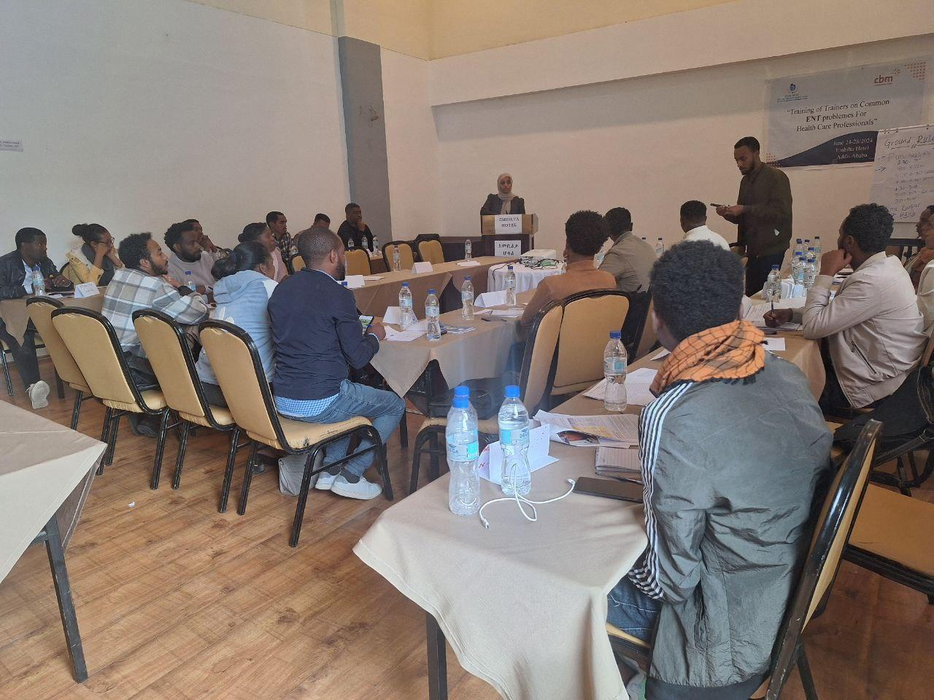 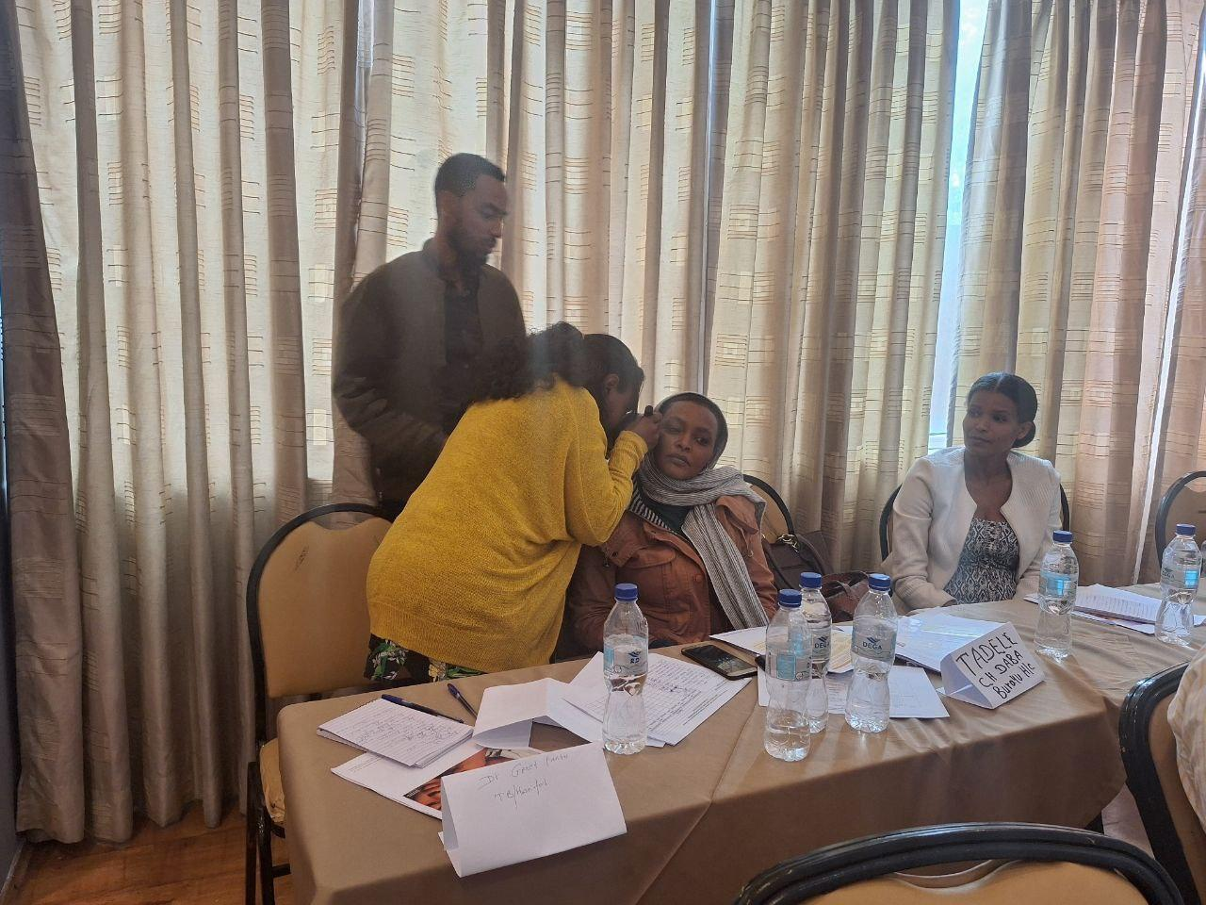

Training of Trainers session at Embilta Hotel on Common EHC problems for Health professionals

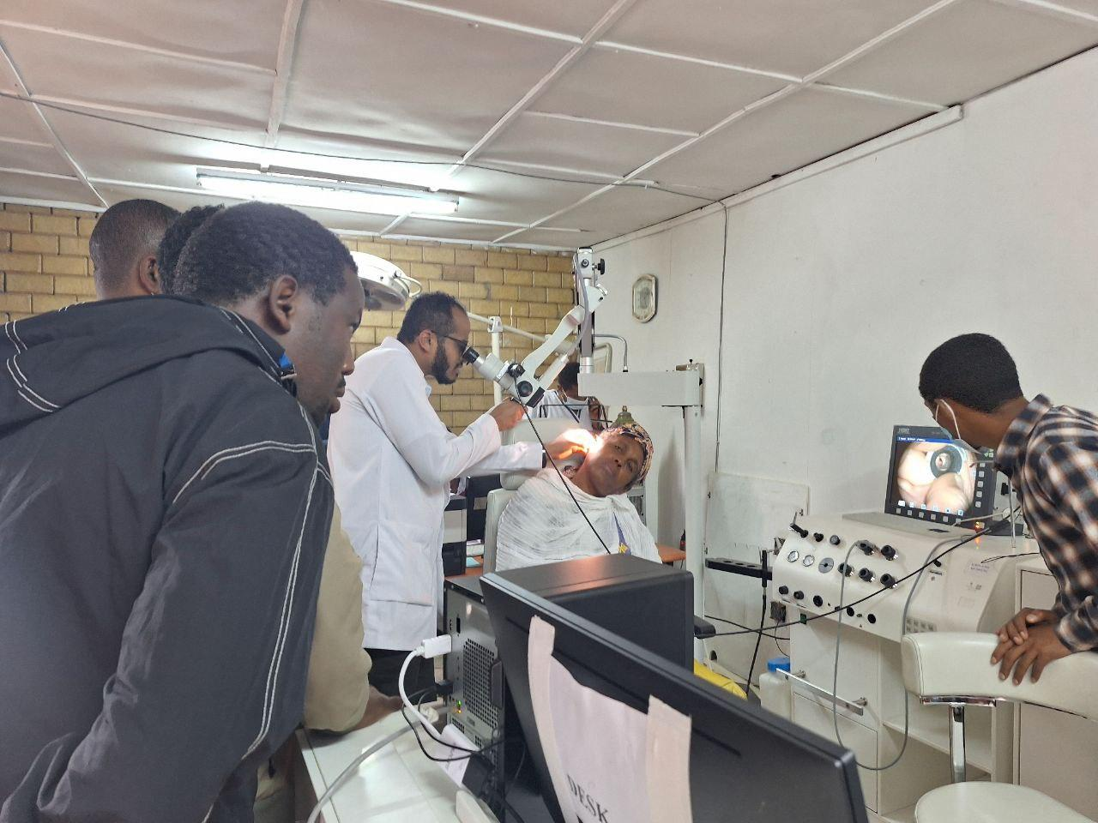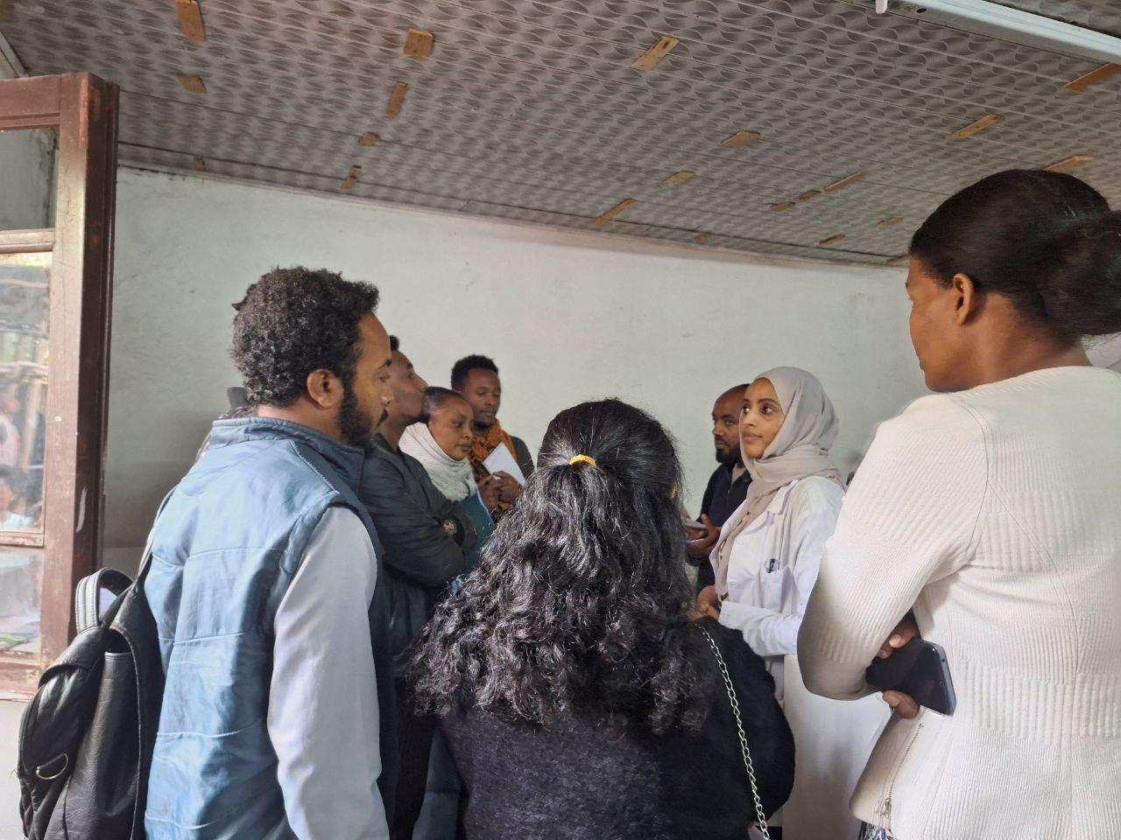

Practical Training of Trainers on ENT Common Health problems Sessions at SPHMMC

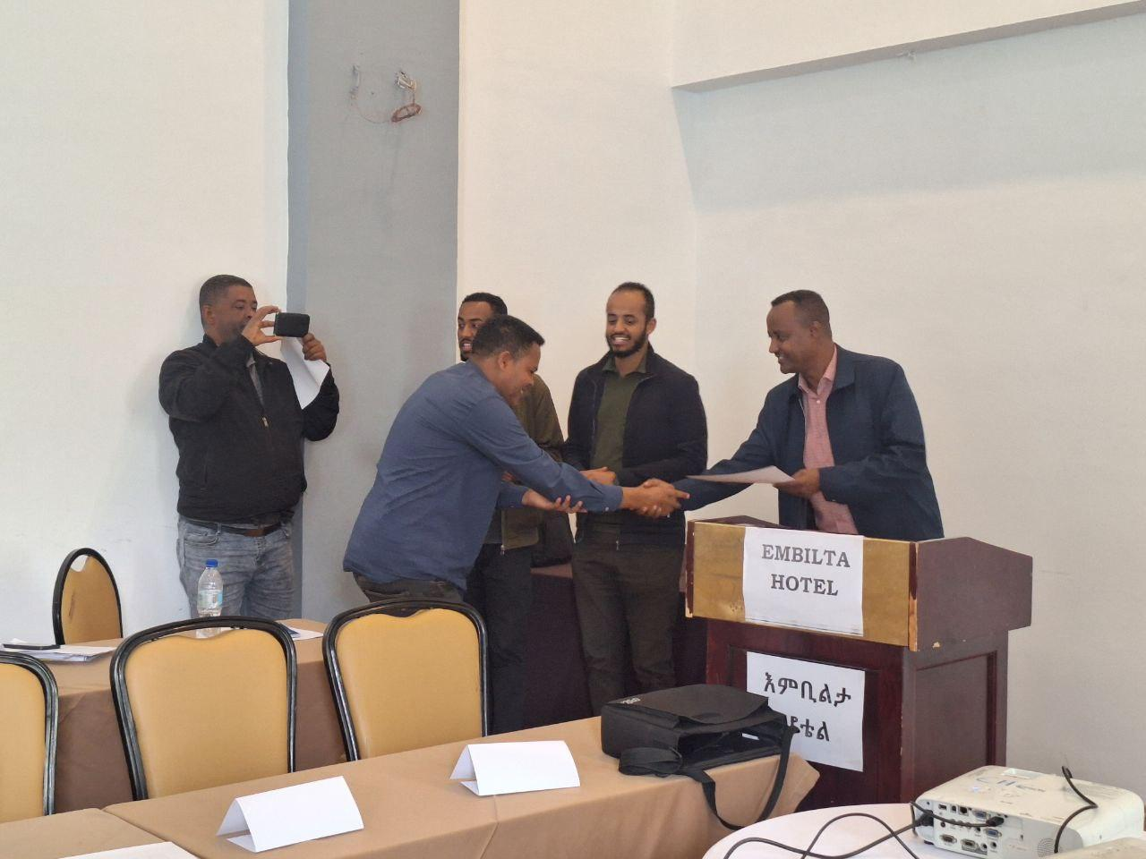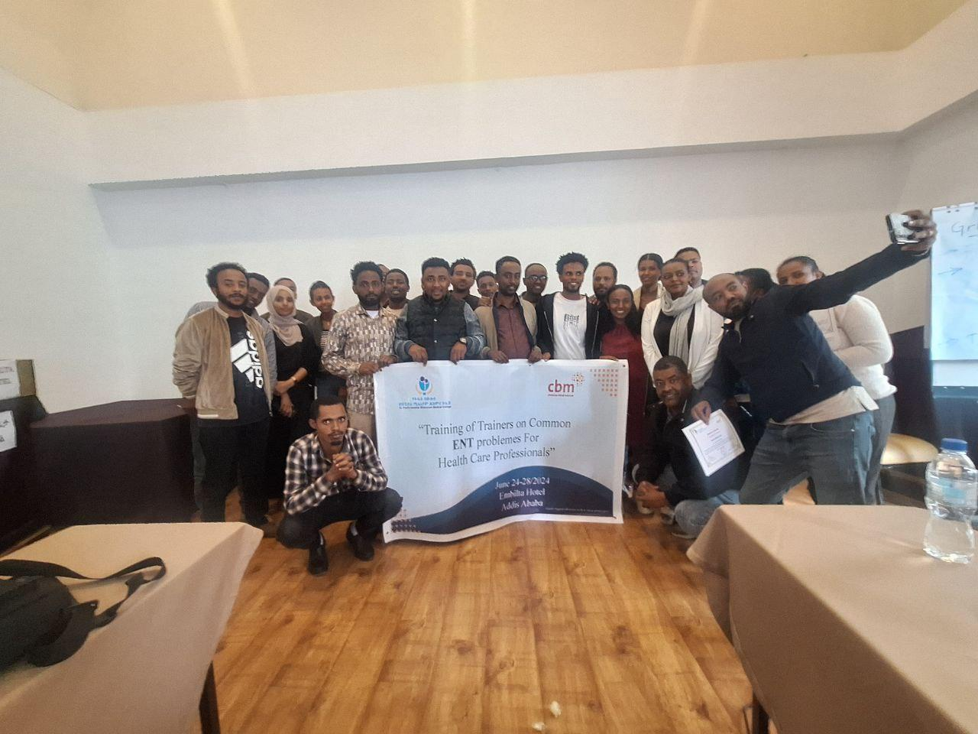

Certification program and trainees Group Photo

# **COMMENTS FROM CBM OFFICE**

During The 1st and 2nd quarters of project implementation period, St. Paul Hospital ENT department implemented the Ear and Hearing Care project(P4257/10140) relatively with significant level of alignment to the original plan and schedule except for result area 04-*EHC mainstreamed through partnership with the Federal Ministry Health of Ethiopia*because of a challenge to resume the Technical Working group Meeting joint plans with the MoH. Outreach activities and collaboration with GTM to strengthen the EHC services at Butajira was also challenged due to security problems. The project performance aligns closely with the planned project activities contributing towards meeting the project specific objectives. It also demonstrated effective project management and coordination to keep the plan going under budget, scope and time. Budget utilization of the requested amount for the quarters is nearly achieved with more than 90% burn rate. Recommendation given on financial management during project monitoring and follow up has showed significant improvement. This includes avoiding overutilization of budget lines over 10% of the approved budget without prior approval from CBM CO. Capturing data during implementation has also improved in regards to capturing, storing and using the data generated during screening and campaigns as a result of renewed coordination between the ENT department and the EHC project. On top of strengthening the provision of EHC services, the partner has also facilitated procurement of medical supplies and equipment through third party payment which contributed the efficient utilization of budget of the project. However, the partner was not able to provide a story with a hearing aid fitting even though, it is reported 6 people received fitting. Hence, I expect the partner to provide at least one during the remaining quarters.

St. Paul also delivered reports fairly timely with expected quality standards sticking to the guidelines in the reporting template under each reportable item. The Report is comprehensive, and provided clear insights into progress and challenges encountered. However, it still requires improvement in timeliness.

In general, with continued support and follow up from CBM, the project would be successful, to complete on time, through meeting its specific objectives after 3rd and 4